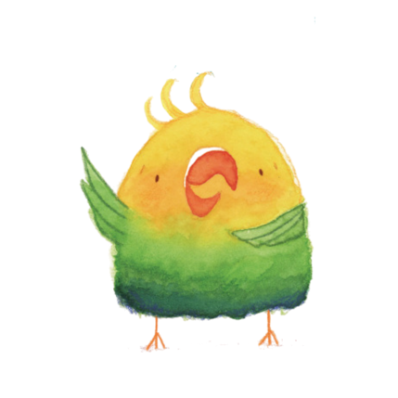

RISSY NO KISSIES
BY KATEY HOWES, ILLUSTRATED BY JESS ENGLE
CAROLRHODA BOOKS, 2021
EDUCATOR RESOURCES

WRITING CRAFT: REPETITION AND VARIATION

Sometimes, authors use the same words over and over in a story. This is called REPETITION. Can you give an example of repetition?

Find an example of REPETITION in the book RISSY NO KISSIES. Show it to a partner, or copy it here.

How many times are these words repeated in the story?

Sometimes, authors repeat words or phrases several times. Then they use ALMOST the same words in another part of the story. This is called VARIATION.

Can you find an example of VARIATION in the book RISSY NO KISSIES? Show it to a partner, or copy it here.

Why would an author use REPETITION?

Why would an author use VARIATION?

WRITING CRAFT: REPETITION AND VARIATION

Now You Try It!

Choose a word or phrase. Write it three times. Then write a variation. For an extra challenge, make your variation rhyme with your repeated phrase. For example:
Do it! Do it! Do it! Chew it!

Draw a picture to go with your repetition and variation.

KEY: WRITING CRAFT: REPETITION AND VARIATION

Sometimes, authors use the same words over and over. This is called REPETITION.

Encourage students to offer examples of repetition from stories, songs, or poems.

Find an example of REPETITION in the book RISSY NO KISSIES. Show it to a partner, or copy it here.
Accept reasonable answers, including all or part of the phrases:
“No kissies!” Rissy chirruped with a most emphatic squeak.
OR
“We know love birds all love kisses...”

How many times is this sentence/these words repeated in the story?

Answers may include:
“’No kissies!’ Rissy chirruped with a most emphatic squeak” appears four times.
“We know love birds all love kisses...” appears four times.

Sometimes, authors repeat words or phrases several times. Then they use ALMOST the same words in another part of the story. This is called VARIATION.

Can you find an example of VARIATION in the book RISSY NO KISSIES? Show it to a partner, or copy it here.

Accept reasonable answers, including all or part of the phrase:
“I’m a Love Bird!” Rissy chirruped with a most emphatic squeak. (page 29)

Why would an author use REPETITION?

Answers will vary and may include:

- to show that something is important
- to get listeners to chime in /participate in the read aloud
- to create predictability/familiarity
- to make something memorable

Why would an author use VARIATION?

Answers will vary and may include:
- to show that something is important
- to get your attention/surprise you
- to prevent boredom

